**Pizza sales SQL Queries**

---Total revenue

select sum(total_price) as total_revenue from pizza_sales



--Average Order Value

select sum(total_price)/count(distinct order_id) as avg_order from pizza_sales

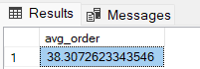

--Total pizzas sold

select sum(quantity) as ttl_pizzas_sold from pizza_sales

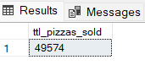

--Total order

select count(distinct order_id) as ttl_order from pizza_sales

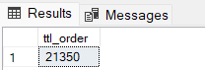

--Average pizza per order

select cast(sum(quantity) as decimal (10,2))/cast(count(distinct order_id) as decimal (10,2)) as avg_pizza_per_order from pizza_sales

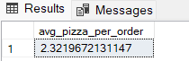

--Daily trend for total orders

select DATENAME(DW,order_date) as order_day, count(distinct order_id)

from pizza_sales

group by DATENAME(DW,order_date)

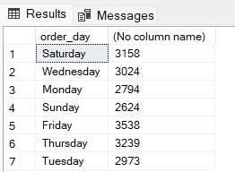

--Monthly trend for total orders

select datename(month,order_date) as order_date,

count(distinct(order_id) ) as month_orders

from

pizza_sales

group by

datename(month,order_date)

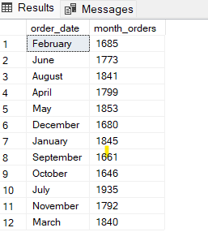

--Percentage of sales by pizza category

select pizza_category,

sum(total_price) *100/(select sum(total_price) from pizza_sales) as percent_of_sales

from pizza_sales

group by

pizza_category

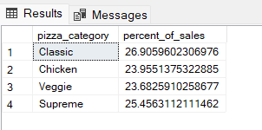

--percentage of sales by pizza_sales

select pizza_size,

sum(total_price) *100/(select sum(total_price) from pizza_sales) as percent_of_sales

from pizza_sales

group by

pizza_size

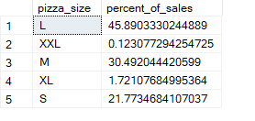

--top 5 pizza_name by revenue

select top 5

pizza_name,

sum(total_price) as revenue

from pizza_sales

group by

pizza_name

order by

revenue desc

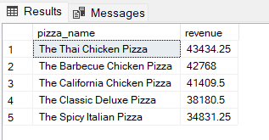

--Bottom 5 pizzas by Revenue

select top 5

pizza_name,

sum(total_price) as revenue

from pizza_sales

group by

pizza_name

order by

revenue

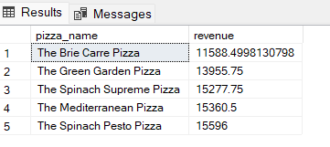

--Top 5 pizzas by Quantity

select top 5

pizza_name,

sum(quantity) as quantity

from

pizza_sales

group by

pizza_name

order by

quantity desc

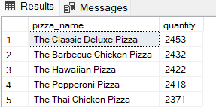

-- bottom 5 pizzas by quantity

select top 5

pizza_name,

sum(quantity) as quantity

from

pizza_sales

group by

pizza_name

order by

quantity asc

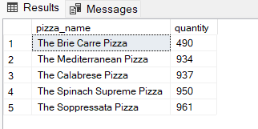

--top 5 pizzas by total orders

select top 5

pizza_name,

count(distinct order_id) as total_orders

from

pizza_sales

group by

pizza_name

order by

total_orders desc

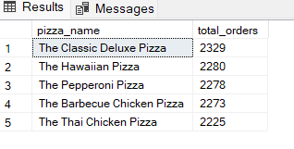

-- bottom 5 pizas by total orders

select top 5

pizza_name,

count(distinct order_id) as total_orders

from

pizza_sales

group by

pizza_name

order by

total_orders

